CSCE 5222 Feature Engineering

Project Report

Group 4

Lakshmi Keerthi Gopireddy

Naga Sanjana Maddula

Bhavya Kanyadara

1. Problem Statement:

A company has multiple images of square components and is trying to automate their quality assurance procedure. They have multiple sets of under or over exposed images, where each image contains multiple square-like objects called components, the company wants to identify the status of each component by inspecting the pattern on it. Each component in good state is considered to be highly valuable. The ground truth is identified by the texture of each component; strip or cross patterns are considered as good and the others are bad. This automation will help the company identify the defects in the components and take necessary actions like discarding the defective pieces or rebuilding them.

1. Aim:

The aim of the project is to apply necessary image preprocessing techniques to improve the quality of the image as well as segment the region of interest, and extract features from the components. The ultimate objective is to train a model or an automated system using the extracted features to classify a component as good or bad.

1. Dataset Understanding:

The given dataset contains 20 JPG files, with 1100 x 1100 dimensions, each containing an image of a circular plate having 27 square shaped components which are considered to be the region of interest. After segmentation of the images, we will have a total of 540 segments or components. We can identify the ground truth of these components by observing the texture on them. The components having stripes or cross patterns are considered are the good ones and the others are considered to be bad. Figure 1 has an example of a good components and a bad component. The good component has line like texture and is on the left-hand side, the one on the right-hand side is a bad component without any visible texture. The model is expected to identify whether a component is good or bad when an image of a new component is given as input. An example image with good and bad components annotated with green and red respectively are shown in Figure 2.

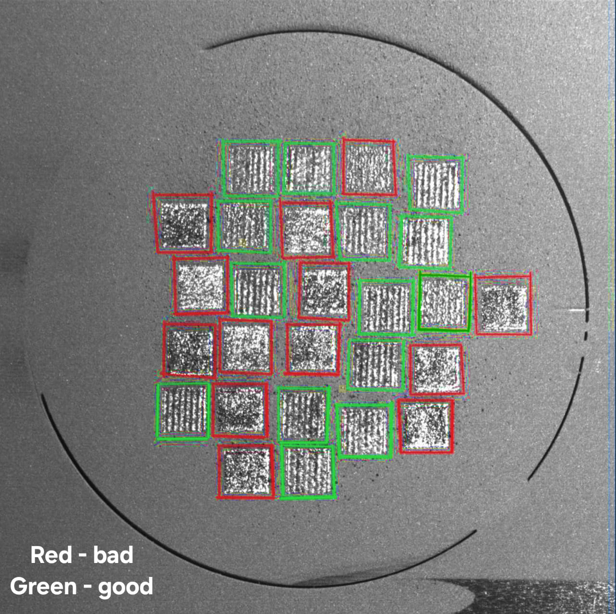

Figure 2: Example annotation of good (green) and bad (red) components in the image

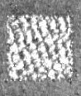 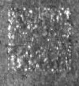

Figure 1: Example of a good (LHS) component and a bad (RHS) component

1. Methodology:

* *Manual Labelling*: It is necessary to know the ground truth of each segment and this can be done by visual inspection depending on the descriptions given by the company. Ground truth includes both the segment boundaries as well as the quality of the component i.e. the label.
* *Exposure Correction:* Exposure of the image should be changed as there are areas in the image where the lighting is dominating the texture on the component. Retinex [1] algorithm will help us to adjust the brightness of the image which will help us to identify the texture easily. As the contrast of the image is effected a lot, we are performing histogram equalization.
* *Noise Reduction:* After adjusting the exposure of the image, noise in the image is to be removed using Gaussian filter, which smoothens the image. We have to make sure that the smoothening level is low to avoid information loss.
* *Edge Detection:* After the image is pre-processed; in order to identify each component in the image, it is necessary for us to detect the edges of the components. This can be done by Canny Edge Detection [2] method, which is used to detect the edges in an image. In this stage we have to ensure that the threshold is selected in such a way that the edges in the texture are not considered.
* *Contour Detection:* From the edge detected image, we have to extract the boundaries of the component by using contour detection techniques [3] which helps us to identify the coordinates of the boundaries of each segment. The image needs to be converted to binary image if necessary before contour detection. Eliminating this method as it was not yielding good results.
* *Connected Component Analysis:* By using the connected component analysis method, where the ROI can be identified by comparing each component with the next and connecting them depending on the similarity. By doing this we are able to detect the areas with similar pixels.
* *Image segmentation*: In this stage we are detecting the boundaries of the component and mapping them on the image using boundary boxes. After detecting the boundaries of the components, each of the component should be segmented across their boundaries and all the pixels inside the boundary should be considered as a component and should be saved as an image for further analysis. These boundaries can be detected by considering the edges detected in the previous steps. Compare with the manually cropped images to understand the quality of segmentation.
* *Feature Extraction*: For extracting the features in the image, i.e. the texture in the component, we will be using the Local Binary Patterns technique [4]. This method is used to detect texture-based features. These features will be an input to the model we are planning to train.
* *Image Augmentation*: Considering the data size is low, we are planning to create augmented images by flipping the images and increasing/decreasing the brightness by a certain amount. This will help us in expanding the size of our dataset.
* *Training an ML Model:* Considering 80% of the segmented images randomly for training a model using Support Vector Machine algorithm [5]. Keeping in mind the size of the dataset and the aim of the project i.e. to identify texture, SVM will be a better option than other complex neural networks. To avoid overfitting of the data, we are planning to train the model using cross-validation method. We will be performing k-fold cross validation and in each fold 70% of the data is considered for training and 10% for validation.
* *Hyperparameter tuning:* Perform hyperparameter tuning on the model and determine the best set of hyperparameters and analyze the performance of the model.
* *Model Testing:* Using the trained model on the remaining 20% of the data (unseen images) to make predictions on the image segments or components. These predictions are compared to the ground truth and the performance of the model is evaluated.

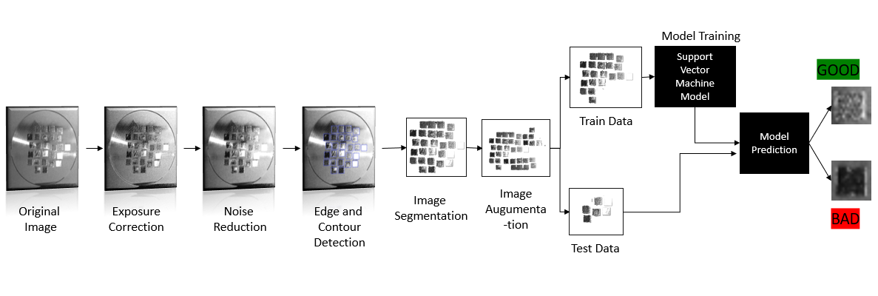

Figure 3: Representation of step-by-step data flow i.e. the project workflow

1. Model Evaluation:

For testing the model, we are considering the 30% data we have kept aside of the purpose. Precision can be one of the best metrics to evaluate the performance of the model. Keeping in mind, the cost of each component is can be high and considering a good component as a defective component and discarding it can cause loss. On the other hand, balancing the number of bad components that are classified as good is also important, so we will be considering F1 score as another important metric. We will also be checking the cross-validation metrics, to ensure the model is not overfitting. To evaluate the quality of image segmentation, we are going to compare the segmented images with manually cropped images using Mean Intersection over Union (mIoU) metric. This will give us the ratio of overlap area vs combined area. Higher mIoU value indicates the segmentation is better.

1. Project Milestones:
2. Ground Truth Detection
3. Image Preprocessing
   1. Exposure Correction
   2. Noise Deduction
4. Image Segmentation
   1. Edge detection
   2. Contour Detection
   3. ROI Separation
5. Image Augmentation
6. Feature Extraction
7. Model Training
8. Hyperparameter tuning
9. Testing and Evaluation of Model
10. Model Performance Improvement
11. Updated Timetable

Table 1: Member-wise task division

|  |  |  |  |  |  |
| --- | --- | --- | --- | --- | --- |
| **Milestones** | **Keerthi** | **Sanjana** | **Bhavya** | **Due Date** | **Status** |
| *Ground Truth Detection* | Yes | Yes | Yes | 11-10-2024 | Done |
| *Exposure Correction* | - | Yes | Yes | 11-10-2024 | Done |
| *Contrast Correction* | - | Yes | Yes | 11-10-2024 | Done |
| *Noise Reduction* | Yes | Yes | - | 11-10-2024 | Done |
| *Edge Detection* | Yes | - | Yes | 11-13-2024 | Done |
| *Contour Detection* | Yes | - | Yes | 11-13-2024 | Done |
| *Connected Component Analysis* | Yes | - | Yes | 11-14-2024 | Done |
| *Image Segmentation* | - | Yes | Yes | 11-16-2024 | Done |
| *Image Augmentation* | Yes | Yes | - | 11-16-2024 | Done |
| *Feature Extraction* | Yes | - | Yes | 11-16-2024 | Done |
| *Model Training* | Yes | Yes | - | 11-17-2024 | Done |
| *Hyperparameter tuning* | - | Yes | Yes | 11-19-2024 | Done |
| *Testing and Evaluation of Model* | Yes | Yes | - | 11-19-2024 | Done |
| *mIoU score Improvement* | Yes | - | Yes | 11-24-2024 | Done |
| *Model Performance Improvement* | Yes | Yes | - | 11-29-2024 | Done |
| *Project Documentation* | Yes | Yes | Yes | 12-02-2024 | Done |

1. Execution details:
2. Ground Truth Detection: We worked on detecting the ground truth by annotating them using rectangular shapes available in the Paint application. In this phase, we detected the ground truth depending on the texture available on the component and in case of doubt we went with the majority. We annotated all 27 components in all 20 images as the first step (Figure 4) and then annotated using green and red color to label them (Figure 5). We saved all these files in a single folder with the same names for easy comparison.

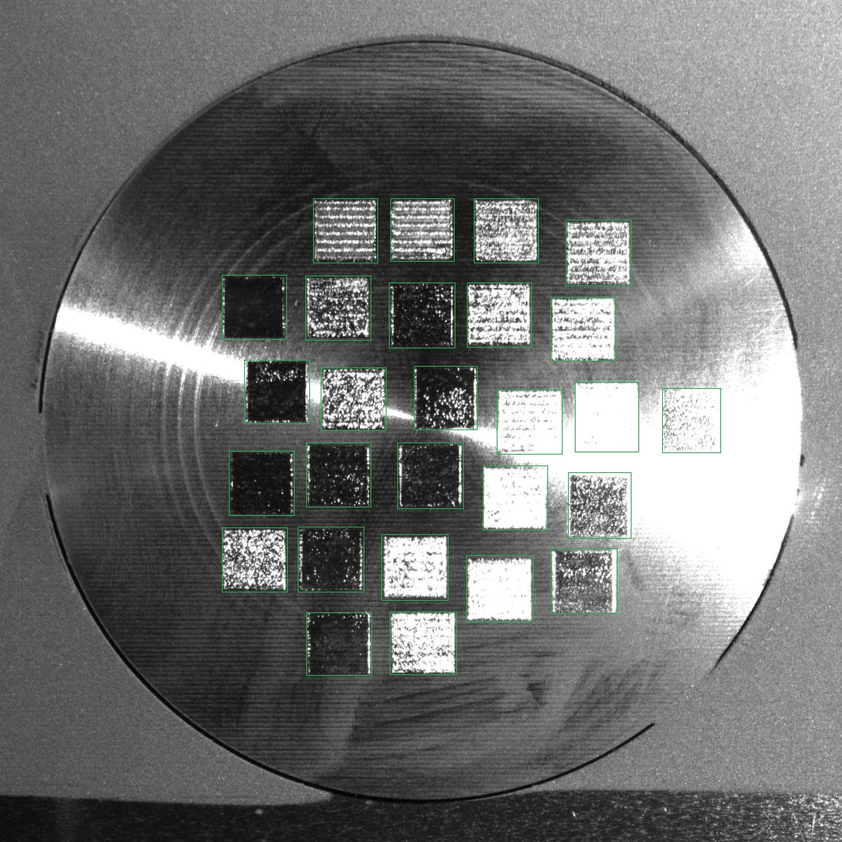

Figure 4: Example of Manually Annotated Image irrespective of Label ( Ground truth for Image Segmentation)

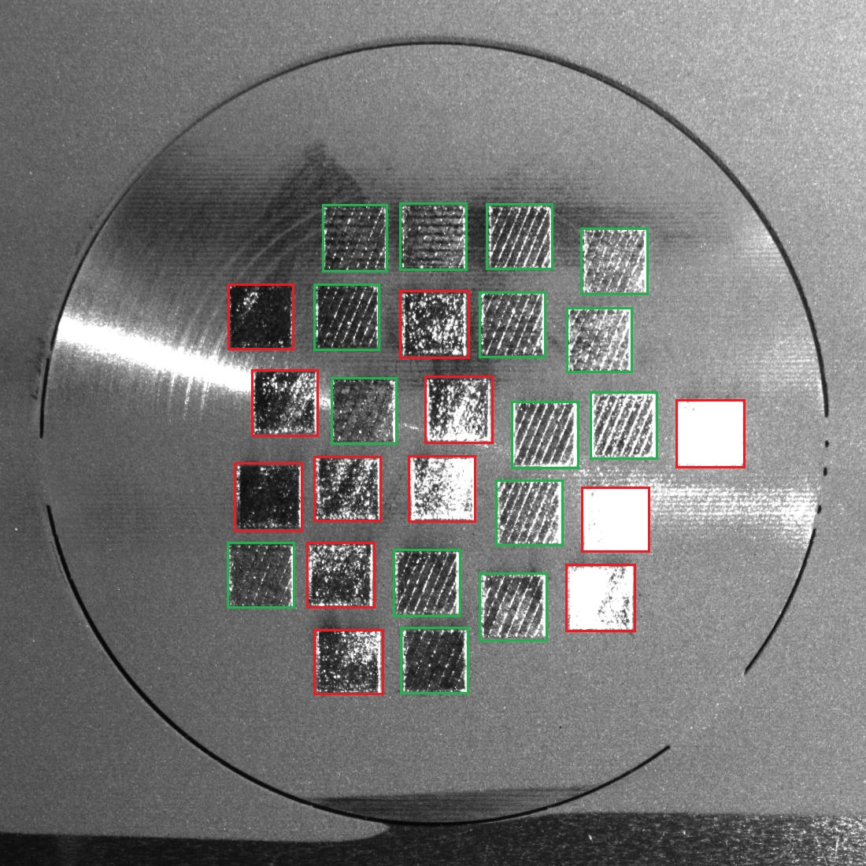

Figure 5: Example of Manually Annotated Image along with Label ( Ground truth for Image Classification)

1. Image Preprocessing
   1. Exposure Correction

For correcting the exposure and extra light in the images, we used the Retinex algorithm which basically takes a pixel and subtracts the average of the pixels beside it. To get the average of the pixels we are using the Gaussian Blur and taking log values. After applying the function on the images, we observed that the images are too grey i.e. the contrast in the image is low. To improve the contrast in the image we are using histogram equalization. By

using this the contrast is enhanced. We are using Contrast Limited Adaptive Histogram Equalization to ensure that the noise is not enhanced and only the necessary regions are enhanced.

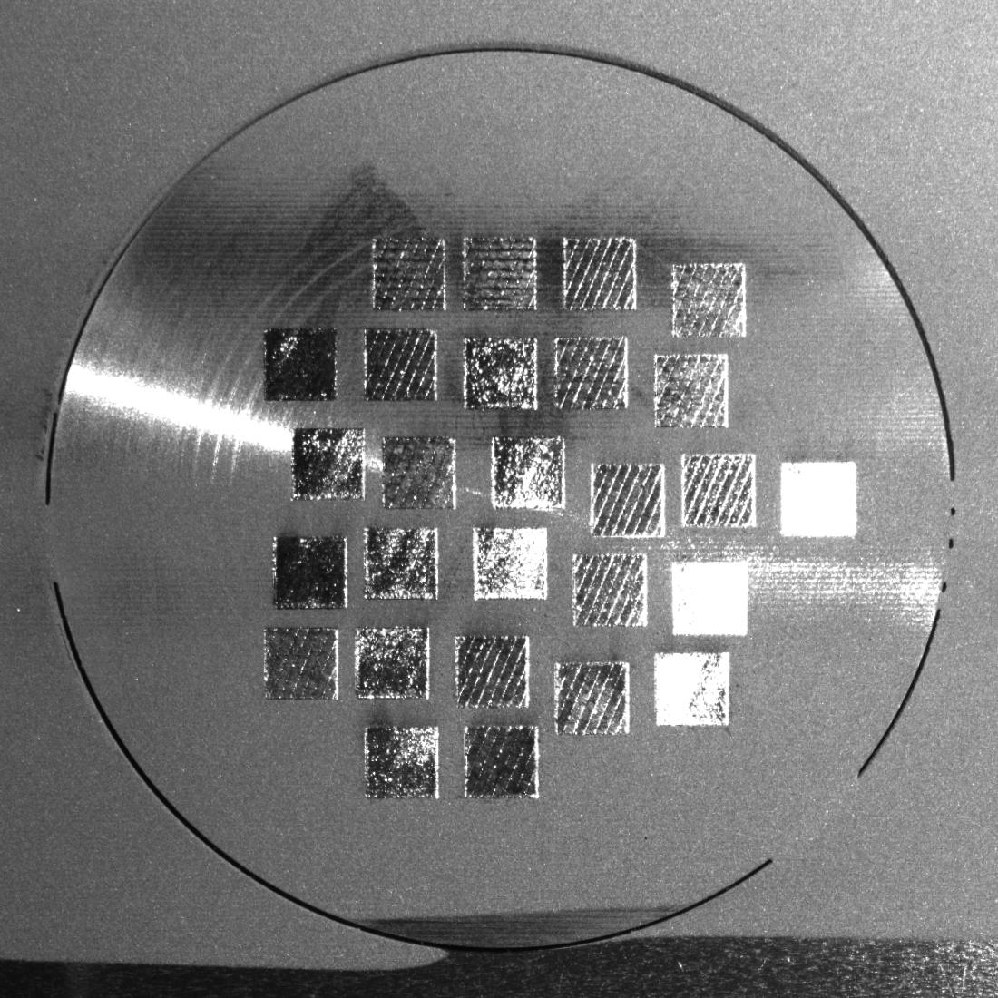 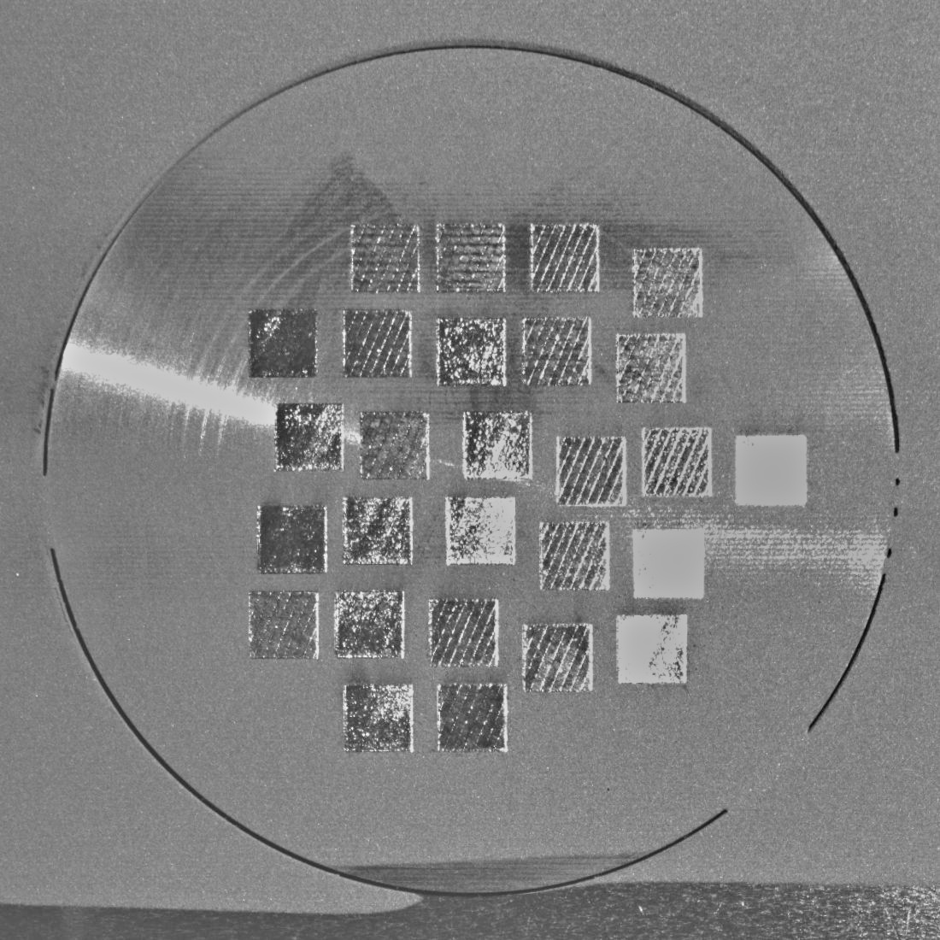

Before After

Figure 6: Comparison of image before and after applying Retinex Algorithm

* 1. Noise Deduction

 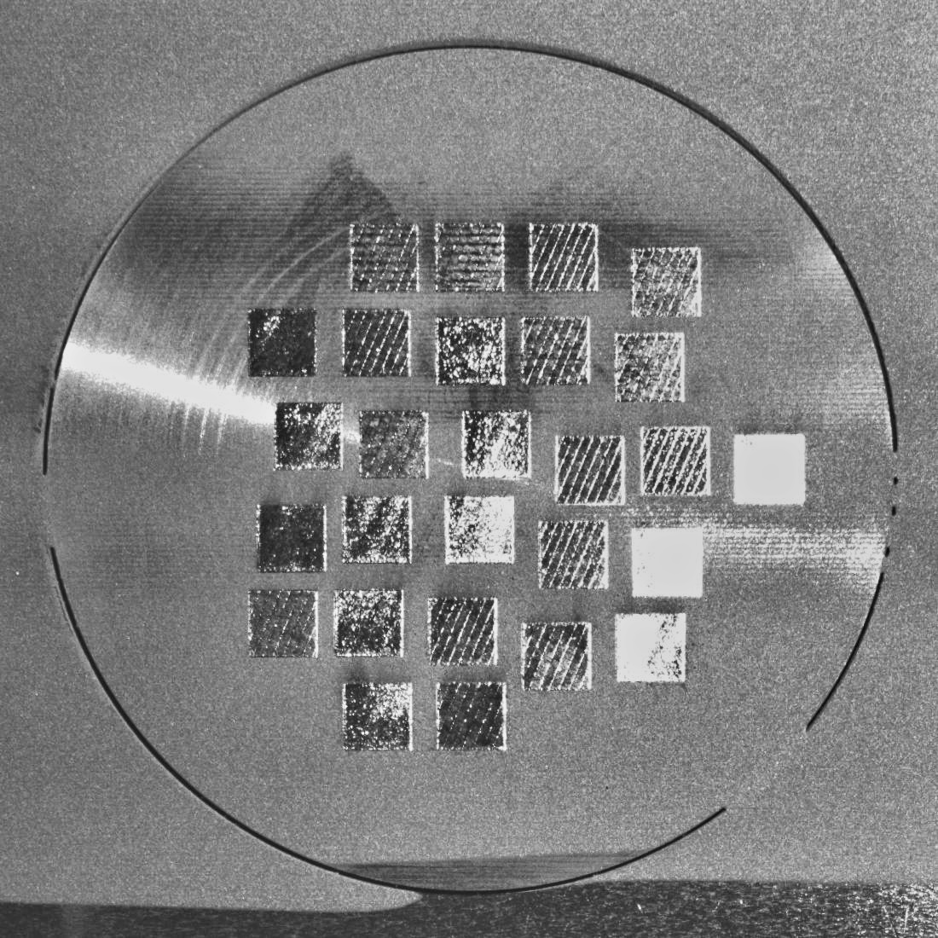

Before After

Figure 7: Comparison of image before and after applying Histogram Equalization

For reducing the noise in the image, we are using the Gaussian Blur function. The sigma value is adjusted in such a way that the edges are identified.

 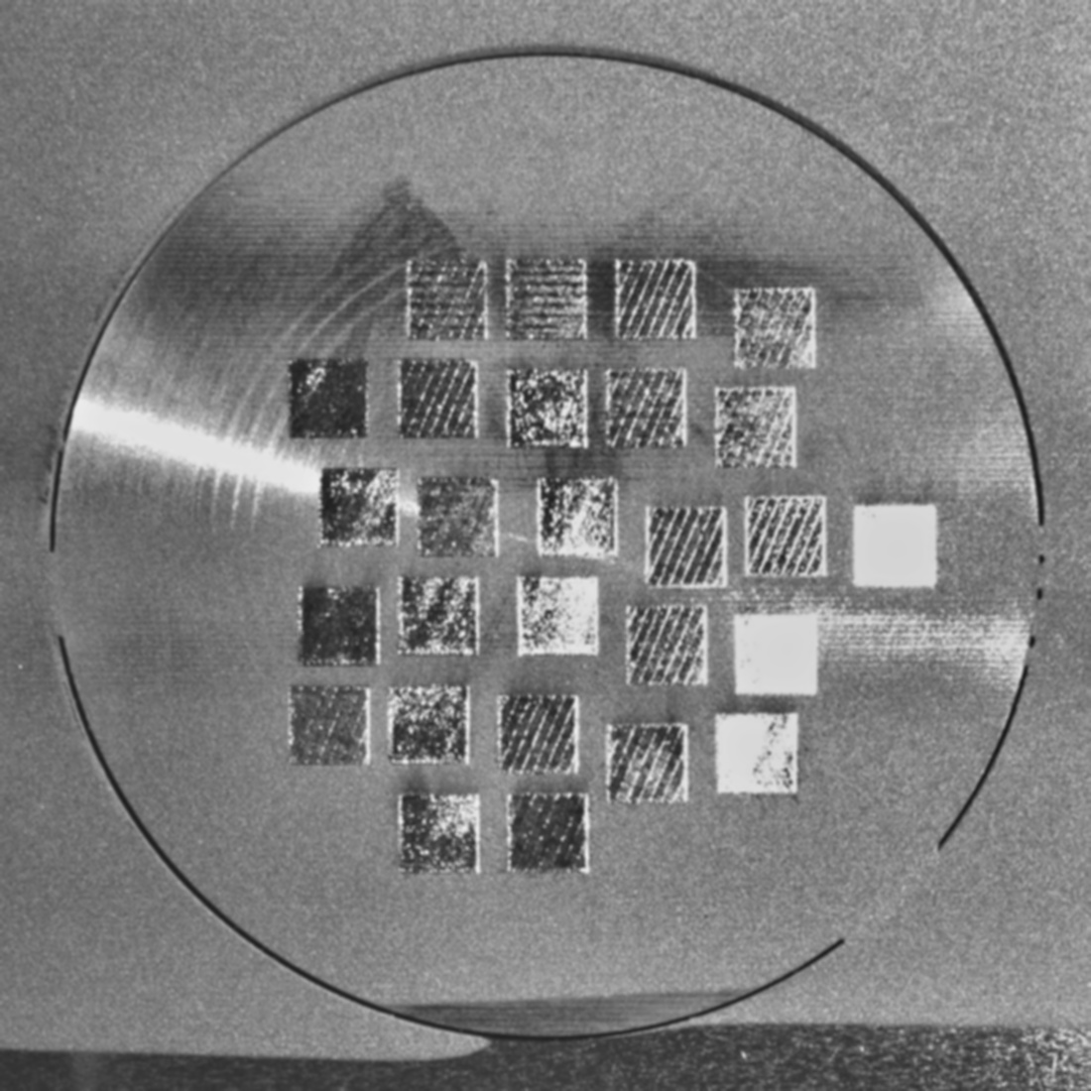

Before After

Figure 8: Comparison of image before and after applying Gaussian Blur

1. Image Segmentation:
   1. Closed Morphology Operation: Using the pre-processed image, we are converting the image to grayscale and filling the noise inside each square using the morphological operations. Closed morphological operation refers to adjusting the pixels inside a closed figure.
   2. Image Sharpening: We are defining a Kernal and passing it through the image and sharpen the edges in the image by focusing on the middle pixel and slighting blurring the neighbouring. This step will be useful for edge detection in the next steps. By adding Closed Morphology Operation and Image Sharpening we observed significant change in the edge detection.
   3. Edge detection: Using the pre-processed image, we are performing Canny edge detection in order to detect the borders of the component. The results of individually implementing edge detection were not sufficient to detect the borders of the component. Using the dilate function we are enhancing the pixels found by 2 iterations.
   4. Hough Transform: Using the Hough transform, which is mainly used to detect shapes, we tried to identify lines followed by square but Canny Edge Detection outperformed.
   5. Contour Detection: In this step we are trying to detect the change in the pixels i.e. the contour in the image post edge detection. In this all components were not detected as shown in the Figure 10.

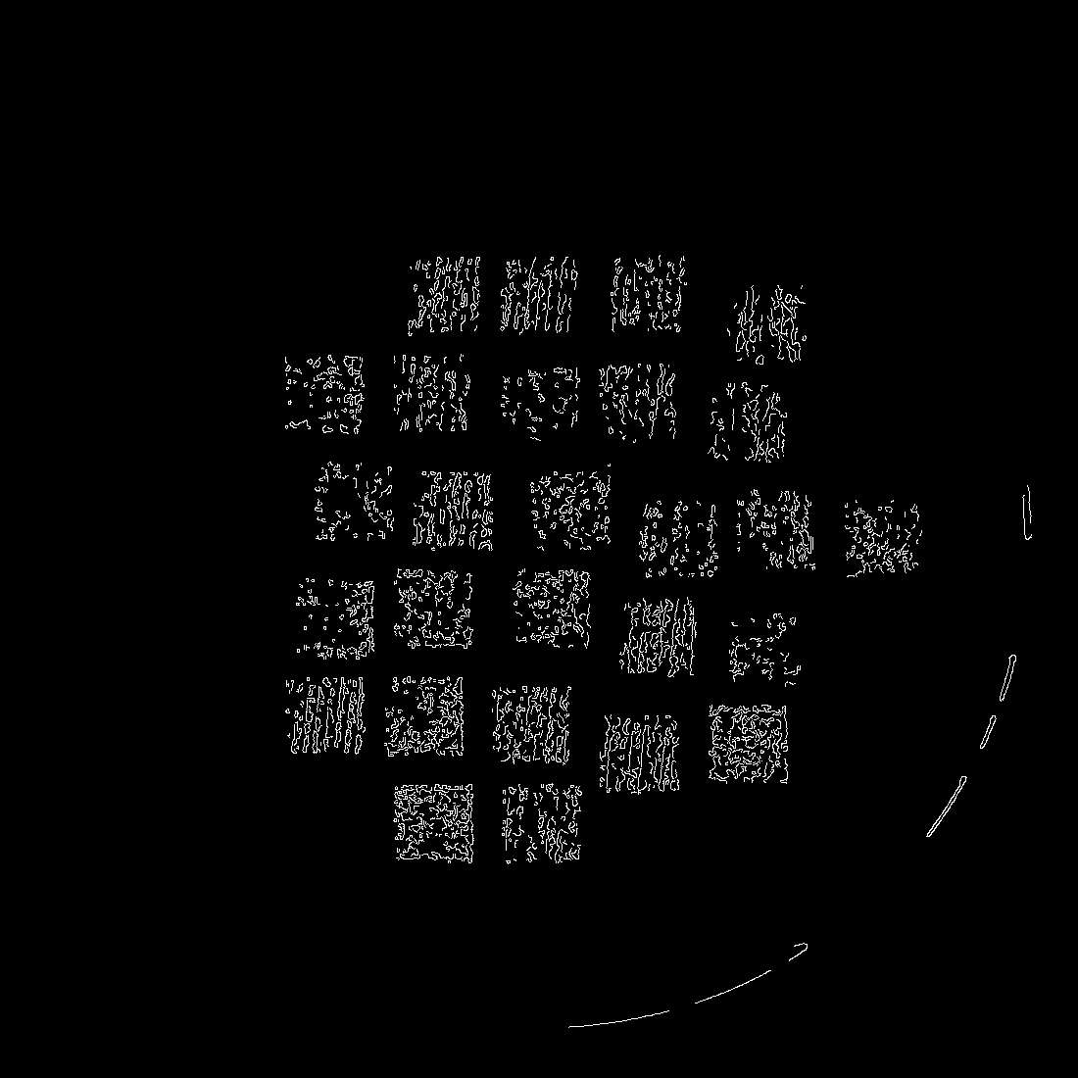

Figure 9: Example of an Canny Edge Detected Image

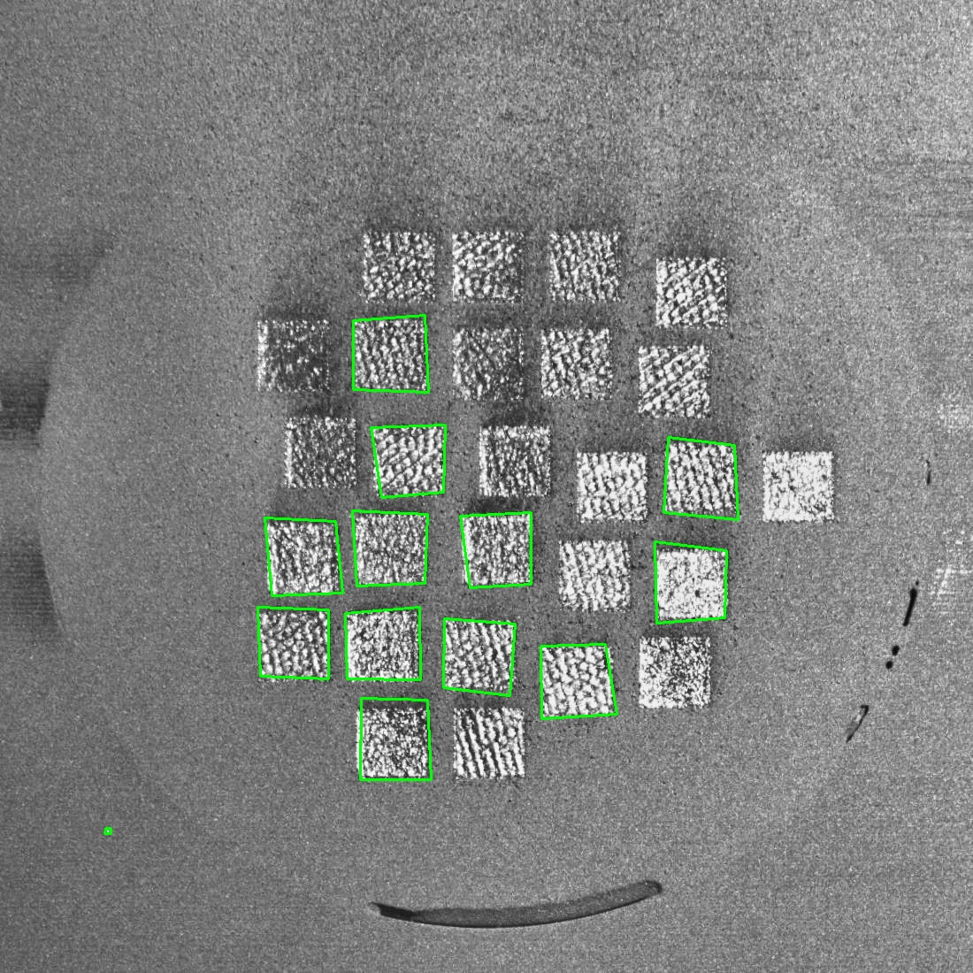

Figure 10: Example output of contour detection on an image

* 1. Connected component analysis: As the results of contour detection were detecting the noise and pattern on the image rather than the borders of the image, we tried the connected component analysis. In this method, the algorithm finds the set of pixels that are connected to each other and are saved. The region is then filtered based on aspect ratio to ensure only the components are detected.
  2. Bounding Boxes: The set of pixels are saved and a boundary box is drawn using an inbuild function from the cv2 library as shown in Figure 11. The number of boxes is limited to 27 as we have 27 components in the image. These 27 boxes are detected by applying conditions over area of the square, aspect ratio.
  3. Hyperparameter tuning: We performed manual hyper-parameter tuning by understand each input for each function and adjusted the parameters as per our understanding. We selected the hyper-parameters which were giving the highest number of components as well as good mIoU score.

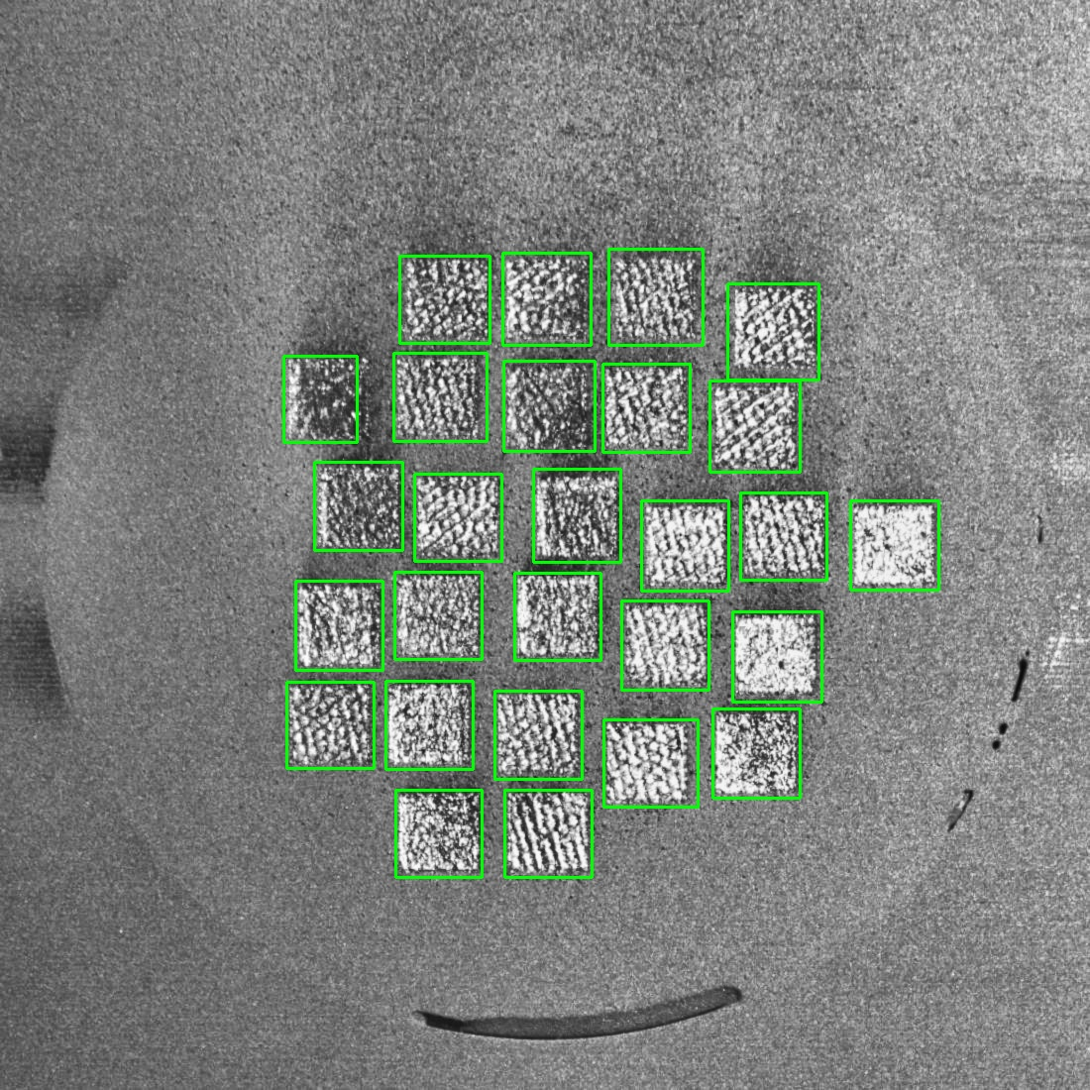 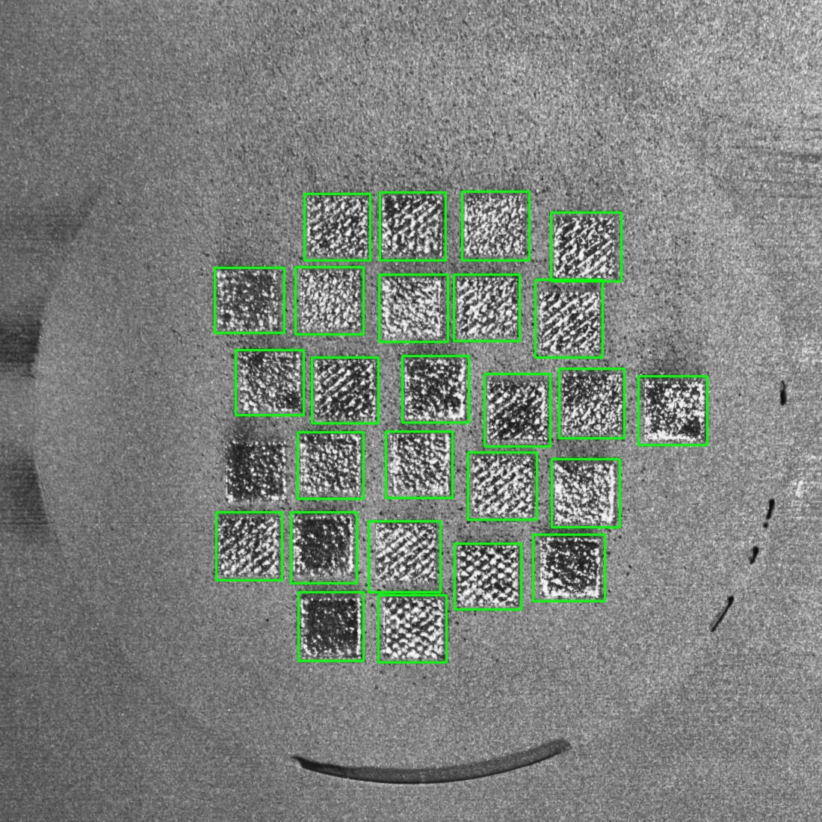 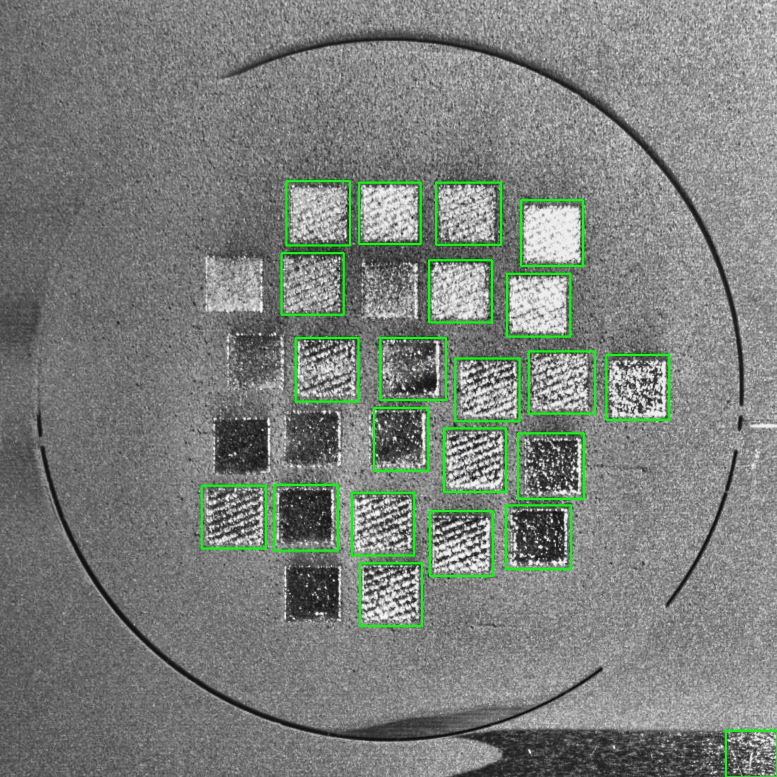

Figure 11: Example output of connected component analysis on an image

1. Snipping the segments:

Considering the segments obtained from connected component analysis and their respective bounding boxes, we are saving each segment as an image. We were able to extract a total of 493 component images from the raw images. These are now stored in a single folder as shown in the figure 12.

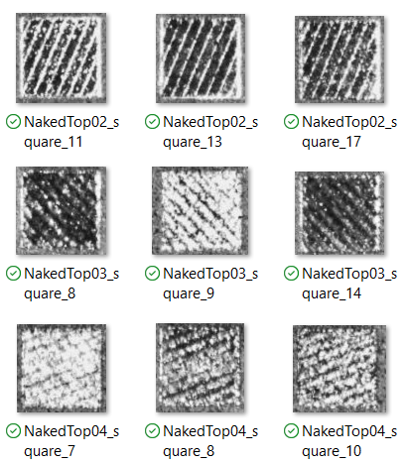

Figure 12: Example of Segmented Components

1. Ground Truth Implementation and Image loading:

Now that we have all the individual segments, the next step is to compare it with the ground truth and separate the good and bad components into separate folders. These folders are also named respectively as good and bad. Using the images in these folders, we are loading them to the environment for further processing. We are maintaining an image size of 100 x 100 to maintain consistency. Each image is labelled with the folder name. The image is stored as an array and the respective labels are also stored as an array. We got an unbalanced dataset with 176 bad components and 317 bad components.

1. Image Augmentation:

As the total number of images we are loading to the environment are 493 which is quite a low number, we are trying to increase the size of the dataset using image augmentation. This is done in order to ensure that the model is able to generalize well. In this step we are trying to balance the dataset as well as increase the total size of the dataset. After performing the image augmentation, the size of the dataset is increased by almost 2 and the number of good and bad components are balanced.

Augmentation involves creating synthetic images by rotating them, adjusting brightness and contrast. For our model, we are randomly assigning a value between 0 to 1 to each image and if the number is below 0.9, then the image augmentation is performed on this image. The image is rotated by 0, 90, 180, 270 randomly and for random images brightness and contrast are adjusted.

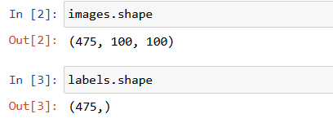 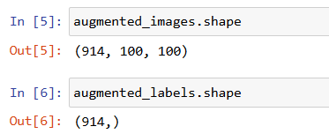

Figure 13: Dataset size before and after image augmentation

After performing image augmentation, the total number of images are 1064 images. The labels of the image are also copied accordingly. The figure 13 has details of the number of datapoints and shape of the images before and after augmentation.

1. Feature Extraction:
   1. Local Binary Patterns: From all the images, we are trying to capture the patterns or texture in each image using texture detection technique named Local Binary Patterns. Local Binary representation is basically the normalized histogram representation of the image. LBP efficiently captures the texture in an image and ignore the pixel intensity i.e. the illumination in the image. This is important as the raw images were effected by external lighting. The feature representation is then scaled from 0 to 1 using a standard scalar in order to ensure that the range of all the images is same. We have also generated the histograms used as input for a random 5 images as shown in figure 14.

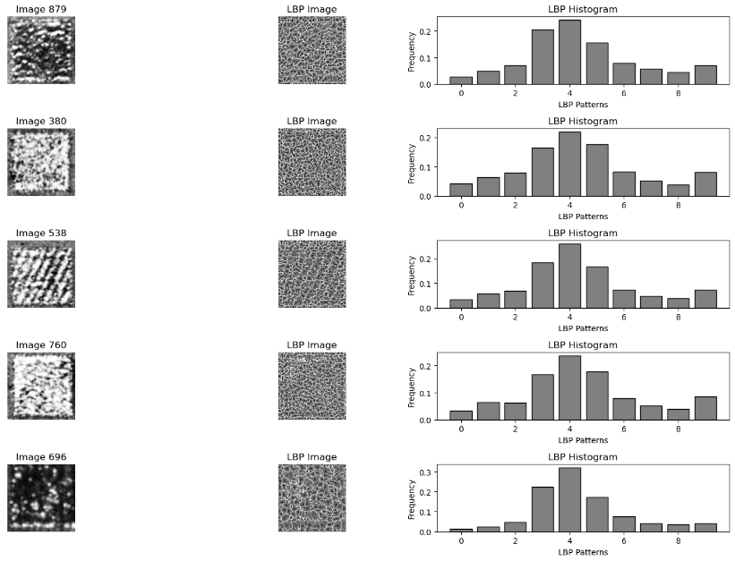

Figure 14: Local Binary Pattern Representation of Images

* 1. Histogram of Gradients (HoG): This method is generally used to detect objects and gradient variations in the image. We are diving an image into multiple cells and histogram of the orientation is captured for each cell. By doing this we get a very large feature space as shown in figure 15. This might lead to curse of dimensionality so we will be performing Principal Component Analysis and limit the number of features to 50 or 100. To find the nest parameters which should be used for training, we are using Grid search and capturing the best parameters that will be suitable for our model.

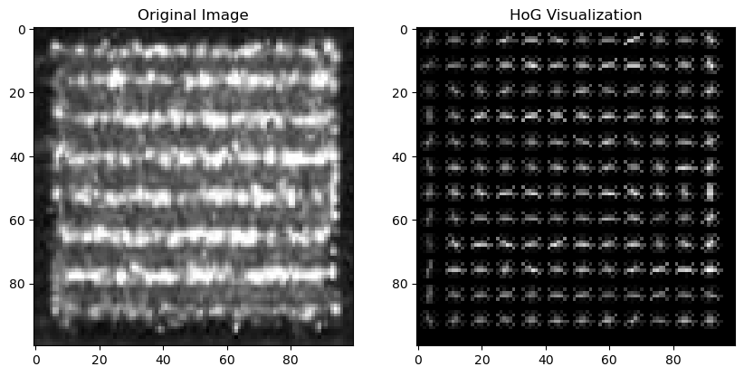

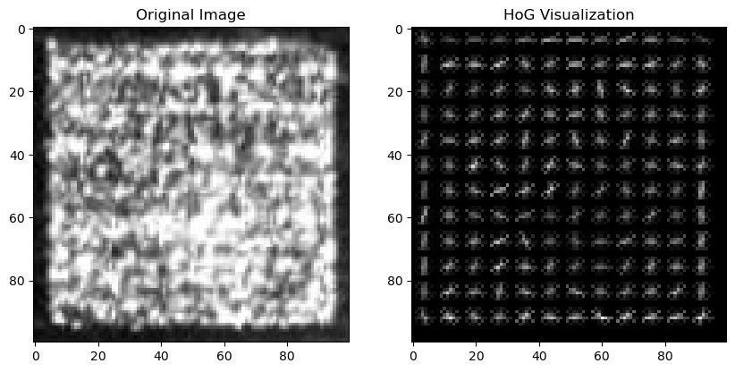

Figure 15: HoG Representation of Images

* 1. Combination of LBP features and HoG features: In this step, we are combining the features obtained from LBP feature extraction method and HoG based feature extraction method. We are appending these features and then performing Principal Component Analysis to reduce the dimensionality. We have additional tried ensemble methods to allow the model to predict using the best model and other methods for feature selection using mutual information.

1. Training a ML Model: Using the features extracted from each technique, we are now trying to train a model using 80% of the whole data available. For this, we are splitting the data into train and test set. Then using the train dataset, we are implementing stratified cross validation technique to split the data into 5 parts and train an SVM model or Random Forest using 4 parts of the data and calculate the accuracy by testing it in the remaining 1 part each time. The parameters which give the best accuracy is considered as the best parameters and are stored separately. The best parameters observed for the model trained with LBP features are in the figure 16.

Using these parameter and Support Vector Machine algorithm or Random Forest Algorithm, we are training the model using the whole train dataset. The model is then saved and used for further predictions.

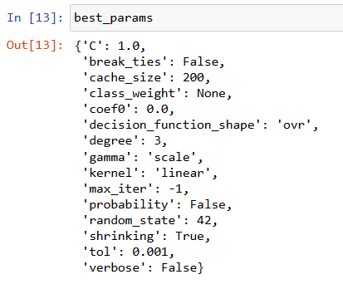

Figure 16: Best Parameters for SVM Model

1. Important Functions:
   1. **Retinex Algorithm:**

For this we are implementing single scale and multi scale Retinex to enhance the image and improve the contrast of the image. We have to give the image as an input and the sigma value for Gaussian blur and it returns an enhanced image as shown in figure 6.

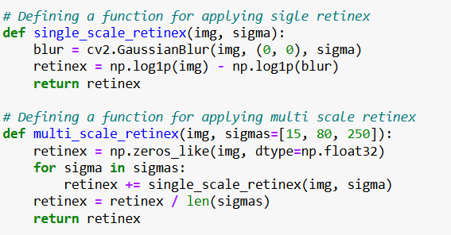

Figure 17: Single and Multi Scale Retinex Functions

* 1. **Fill Mask Function:**

Fill mask function uses binary masks and morphological closing operations, in order to fill the gaps in the image. This uses a kernel to identify the areas where this operation has to be performed This takes gray scale image as input and returns the processed image after filling the gaps inside the mask.

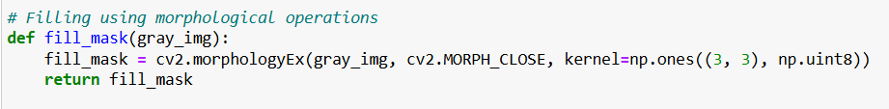

Figure 18: Fill Mask Function

* 1. **CLAHE Function:**

This applies Contrast, Limited, Adaptive Histogram Equalization to improve the local contrast and to enhance the image. This takes a BGR or gray scale image as an input and uses a clip limit to equalize and gives back an enhanced image.

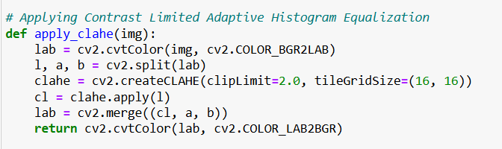

Figure 19: CLAHE Function

* 1. **Check Aspect Ratio and Area Function:**

This function is created to check the aspect ratio and area of the bounding rectangles. After the boxes are identified by the model this function is applied in order to filter the needed bounding boxes. This takes the bounding box the minimum and the maximum area criteria as the input and returns true of false depending on the criteria

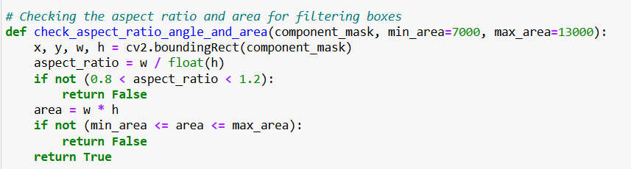

Figure 20: Check Aspect Ratio and Area Function

* 1. **Finding the Connected Components Function:**

In this function we take the image and apply necessary sharpening and denoising of the image before detecting the edges. The next step is to detect the edges using canny edge detector with a high and low threshold and dilate the image twice. The connected components in this image are identified and are stored. Keeping the square count as 27 we are drawing green boxes for each connected component and tracing them on the original image. This takes the pre-processed image, original image and the file name as input and gives out the image with bounding boxes along with the square count in each image. This function also stores each bounding box as a separate image in the mentioned file path.

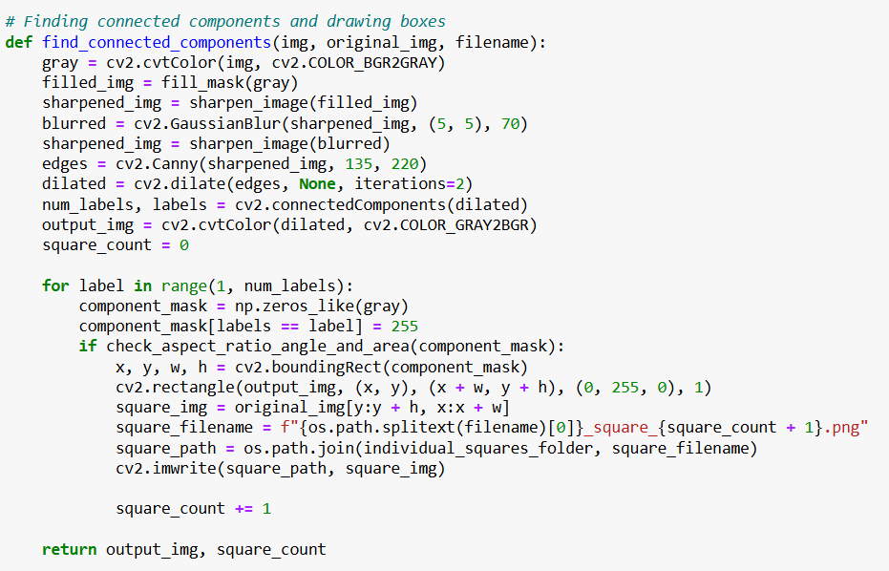

Figure 21: Finding the Connected Components Function

* 1. **Process Dataset Function:**

This function is used to perform the initial pre-processing which includes CLAHE and Multiscale Retinex operations. The resulting image from these two operations is then combined and given to the find connected components function. This also displays the total number of squares detected across all images. This function takes the input folder and the output folder paths as input.

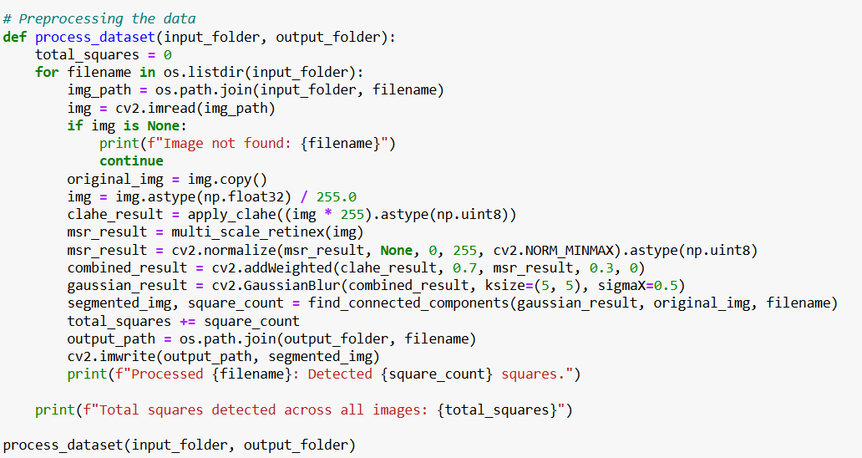

Figure 22: Process Dataset Function

* 1. **mIoU Calculation Function:**

This function is used to calculate the mean intersection over union of the detected boxes to the ground truth. This takes annotated boxes which is the ground truth and detected boxes, image shape as input and returns mIoU score annotated masks and detected masks as output.

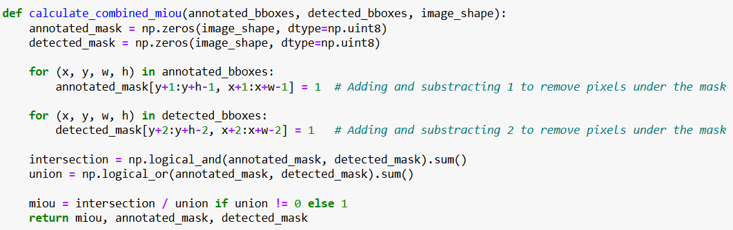

Figure 23: mIoU Calculation Function

* 1. **Find bounding boxes Function:**

This function is used to detect the bounding boxes in green colour and return them to the variable this takes the image and color range as input and gives out the bounding box as output.

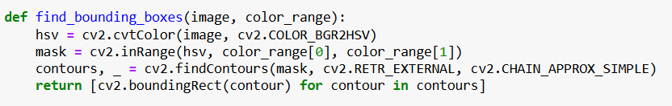

Figure 24: Find bounding boxes Function

* 1. **Calculate MIoU for all images Function:**

This function reads all detected images and the annotated ground truth compares each detected masks to the annotated masks and gives mIoU values for each image. This function also displays the ground truth mask and detected mask for comparison.

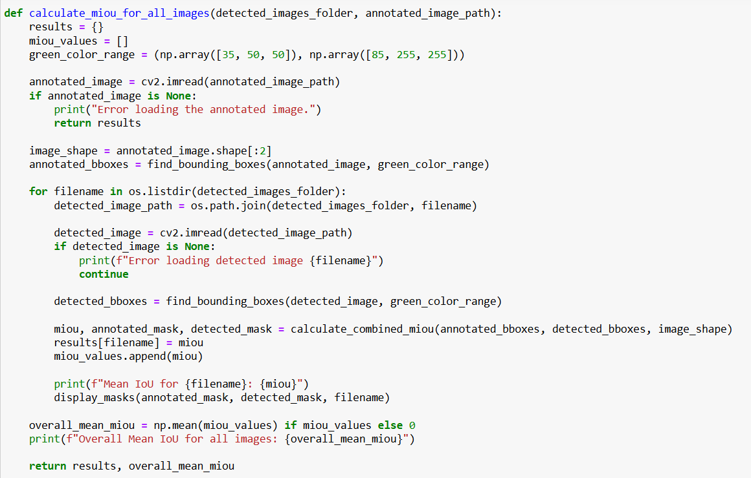

Figure 25: Calculate MIoU for all images Function

* 1. **Image augmentation Function:**

This function is uses to augment any image. This contains a function to randomly rotate the image, randomly enhance the brightness of the image and randomly adjust the contrast of the image. After applying random augmentation, the image is resized to the original size. This function takes an original image as input and gives out an augmented image.

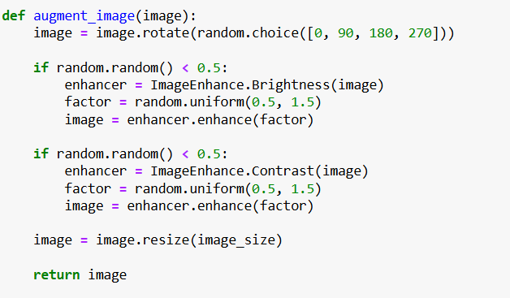

Figure 26: Image augmentation Function

* 1. **Extraction of LBP feature Function:**

This function is used to extract local binary pattern features from the image which are basically the histogram form of each image. This technique is used to identify the textures in the image. This function takes image, neighbour points, Radius of the circular neighbourhood as input and gives out LBP features and normalised histogram as output.

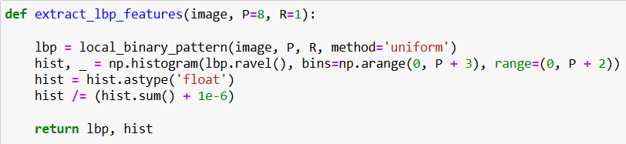

Figure 27: Extraction of LBP feature Function

* 1. **Extraction of HOG features Function:**

This function is used to detect histogram of gradient in the image which can be used as features for the model this takes image, pixels per cell, cells per block and orientation as input and gives out the HOG features.

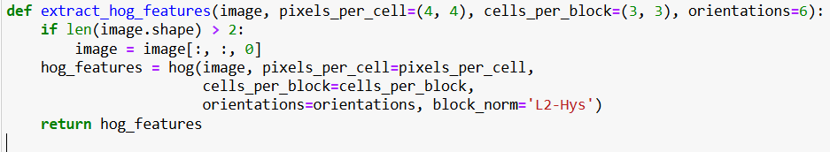

Figure 28: Extraction of HOG features Function

1. Results:

**Segmentation Results:** For comparing the bounding boxes to the ground truth, we are considering an image and annotating it manually using rectangle box in the Paint application. These are drawn in green color. We are using this image as a reference as all the images have segments in the same place. Considering this to be the reference image, we are considering this as the mask i.e., the area inside the mask is turned to white and the remaining pixels are black. This is done in order to calculate the mIoU metric. The mean Intersection over Union metric is basically the intersection region between 2 images over the union of the two images.

For calculating the mIoU score of the annotation performed, we are setting all the pixels inside the detected or annotated boxes to white color and the remaining to black. By doing this the area can be compared. An example of the annotated mask and an example of the mask on segment detected through connected component analysis is shown in figure 29. The mIoU of the images in figure 29 is 0.8819.

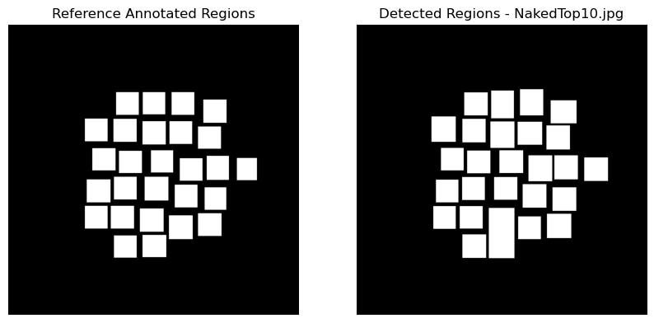

Figure 29: Example of Masked Manually Annotated and Detected Images used for mIoU Calculation

The mIoU for each image is given below:

Table 2: mIoU scores of each image

|  |  |  |
| --- | --- | --- |
| **File Name** | **Gaussian Blur + Canny Edge Detection** | **Morphology + Sharpening + Gaussian Blur + Canny Edge Detection** |
| NakedTop01.jpg | 0.5619 | 0.598269 |
| NakedTop02.jpg | 0.692 | 0.805756 |
| NakedTop03.jpg | 0.5798 | 0.716341 |
| NakedTop04.jpg | 0.6631 | 0.708542 |
| NakedTop05.jpg | 0.8297 | 0.699226 |
| NakedTop06.jpg | 0.7595 | 0.816693 |
| NakedTop07.jpg | 0.7771 | 0.812067 |
| NakedTop08.jpg | 0.7845 | 0.89338 |
| NakedTop09.jpg | 0.6417 | 0.775117 |
| NakedTop10.jpg | 0.8522 | 0.881951 |
| NakedTop11.jpg | 0.7493 | 0.783345 |
| NakedTop12.jpg | 0.6426 | 0.687413 |
| NakedTop13.jpg | 0.7755 | 0.809578 |
| NakedTop14.jpg | 0.7246 | 0.794894 |
| NakedTop15.jpg | 0.7871 | 0.85878 |
| NakedTop16.jpg | 0.838 | 0.868121 |
| NakedTop17.jpg | 0.694 | 0.701481 |
| NakedTop18.jpg | 0.7766 | 0.855945 |
| NakedTop19.jpg | 0.8106 | 0.834121 |
| NakedTop20.jpg | 0.674 | 0.855312 |

*The overall average mIoU for all images is in the last update:* **0.7306**

*The overall average mIoU for all images is in the latest method:* **0.7878**

We can see that the mIoU score has increase in all images except for one. The overall mIoU has also increase and the number of components the model was able to find has also increased from **480 to 493**.

**Model Performance:** We have run a total of 10 models and the respective accuracy, precision, recall and f1 score and given in the Table 3.To understand the performance of the best model w.r.t. f1 score, we captured the classification metrics when the model was used to predict the labels of the images available in test data. The confusion matrix and classification report are available in the figure 30.

Table 3: Performance Metrics of Models Trained

|  |  |  |  |  |  |  |
| --- | --- | --- | --- | --- | --- | --- |
| **Preprocessing** | **Model** | **Feature Extraction Method** | **Accuracy** | **Precision** | **Recall** | **F1-score** |
| Gaussian Blur + Canny Edge Detection | SVM | Local Binary Patterns | 0.77 | 0.78 | 0.77 | 0.76 |
| Gaussian Blur + Canny Edge Detection | SVM | HoG Features | 0.67 | 0.67 | 0.67 | 0.67 |
| Gaussian Blur + Canny Edge Detection | SVM | LBP + HoG Features | 0.69 | 0.69 | 0.69 | 0.69 |
| Morphology + Sharpening + Gaussian Blur + Canny Edge Detection | SVM | Local Binary Patterns | 0.87 | 0.87 | 0.87 | 0.86 |
| Morphology + Sharpening + Gaussian Blur + Canny Edge Detection | SVM | HoG Features | 0.75 | 0.75 | 0.75 | 0.74 |
| Morphology + Sharpening + Gaussian Blur + Canny Edge Detection | SVM | HoG Features + PCA | 0.83 | 0.83 | 0.83 | 0.83 |
| Morphology + Sharpening + Gaussian Blur + Canny Edge Detection | SVM | LBP + HoG Features + PCA | 0.86 | 0.87 | 0.86 | 0.86 |
| Morphology + Sharpening + Gaussian Blur + Canny Edge Detection | Ensemble SVM | LBP + HoG Features + PCA | 0.82 | 0.84 | 0.82 | 0.82 |
| Morphology + Sharpening + Gaussian Blur + Canny Edge Detection | Random Forest | Local Binary Patterns | 0.88 | 0.88 | 0.88 | 0.88 |
| Morphology + Sharpening + Gaussian Blur + Canny Edge Detection | Random Forest | LBP + HoG Features + PCA | 0.89 | 0.89 | 0.89 | 0.89 |

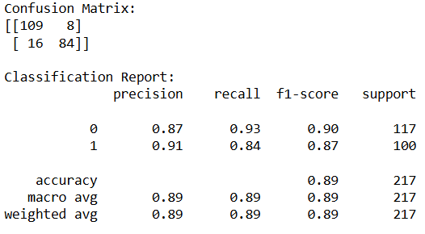

Figure 30: Confusion Matrix and Classification Report

This is the confusion matrix of the model that is giving the best accuracy as well as F1 score. The model giving the best score is the Random Forest Model trained using the features obtained by both Local Binary Pattern and Histogram of Gradients (along with PCA). We can understand that the model was able to predict 109 good components as good (True Positive) and 84 bad components as bad (True Negative). The weighted average of the precision is 0.89, recall is 0.89 and the f1 score is **0.89**. The balance in recall and precision indicate that the model is not overfitting to the data and is able to generalize well. The accuracy of the model is **0.89**. The model is performing well on both train and test data so we can consider this model is able to classify well without overfitting. Using this model, we can identify whether a component is good or bad when any new component is passed through this phase.

1. Conclusion:

In this project, we have created a model which will be able to detect the components in an image, segment them into separate images and classify whether the component is good or bad. This implementation is done by using multiple image processing techniques like Gaussian Blur/ Retinex, edge detection techniques like Canny or Contour Detection, feature extraction techniques like Local Binary Pattern/Histogram of Gradients and Machine learning models like Support Vector Machine/ Random Forest.

1. References
2. Li, M., Liu, J., Yang, W., Sun, X., & Guo, Z. (2018). Structure-revealing low-light image enhancement via robust retinex model. IEEE Transactions on Image Processing, 27(6), 2828-2841. <https://ieeexplore.ieee.org/document/8304597>
3. Rong, W., Li, Z., Zhang, W., & Sun, L. (2014, August). An improved CANNY edge detection algorithm. In 2014 IEEE international conference on mechatronics and automation (pp. 577-582). IEEE. <https://ieeexplore.ieee.org/abstract/document/6885761>
4. Malik, J., Belongie, S., Leung, T., & Shi, J. (2001). Contour and texture analysis for image segmentation. International journal of computer vision, 43, 7-27. [https://link.springer.com/article/10.1023/A:1011174803800](https://link.springer.com/article/10.1023/A:1011174803800%20)
5. Mäenpää, T., & Pietikäinen, M. (2005). Texture analysis with local binary patterns. In Handbook of pattern recognition and computer vision (pp. 197-216). <https://www.worldscientific.com/doi/abs/10.1142/9789812775320_0011>
6. Chapelle, O., Haffner, P., & Vapnik, V. N. (1999). Support vector machines for histogram-based image classification. IEEE transactions on Neural Networks, 10(5), 1055-1064. <https://ieeexplore.ieee.org/abstract/document/788646>